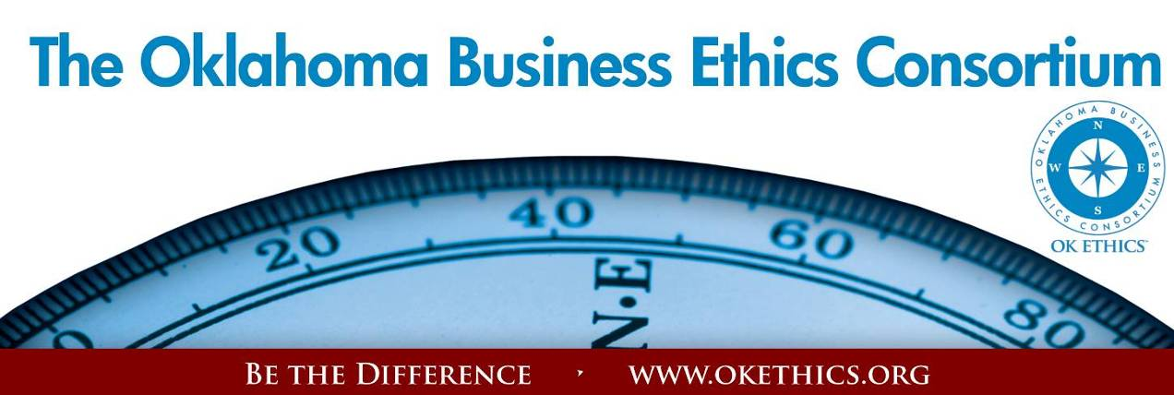
Agenda – August 8, 2012
- Membership Drive – Garyl Geist, Chief Operating Officer, Oklahoma Asthma
& Allergy Clinic; President, OK Ethics (State) Board of Directors

Special thanks to CHESAPEAKE, DEVON ENERGY, HOBBY LOBBY
& SANDRIDGE ENERGY AS OUR FIRST PINNACLE MEMBERS!
Welcome: HIGH MOUNT EXPLORATION & PRODUCTION – New Horizon Member
PACESETTERS FOR FY12-13!
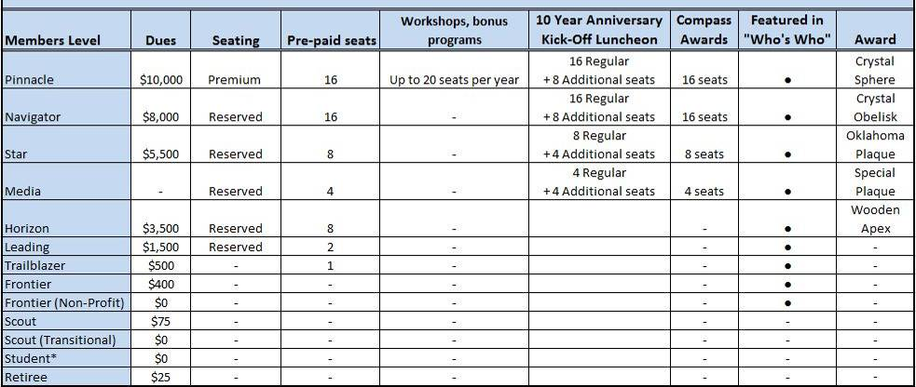
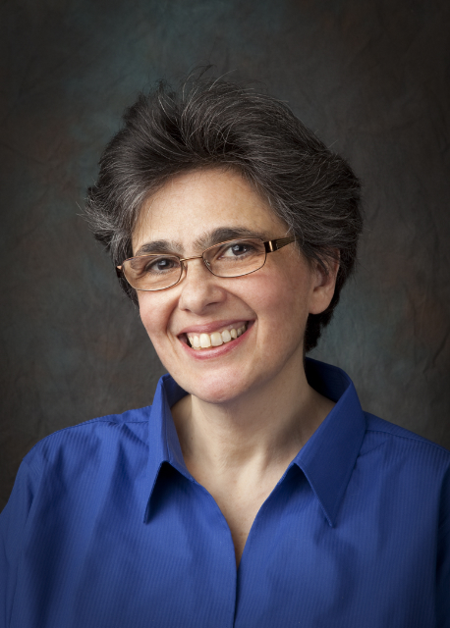
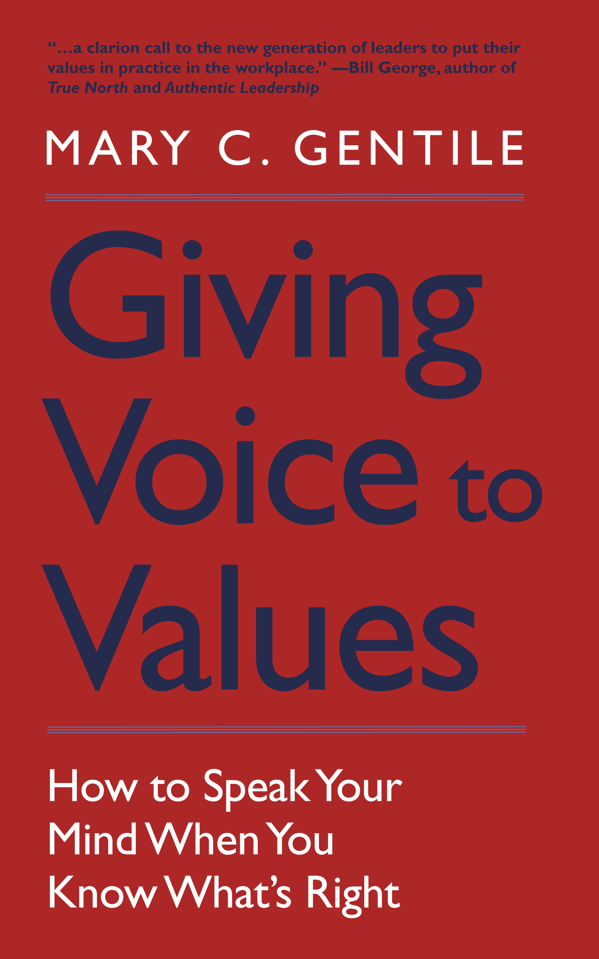
II. Student/Educator Initiatives – Shannon Hiebert, Vice President of Human Resources,
Enterprise Holdings; President, OK Ethics Foundation

STATEWIDE EDUCATORS ETHICS SYMPOSIUM
SEPTEMBER 5 – SOUTHERN NAZARENE UNIVERSITY
STUDENT ETHICS CHALLENGE
October 13 – UNIVERSITY OF OKLAHOMA
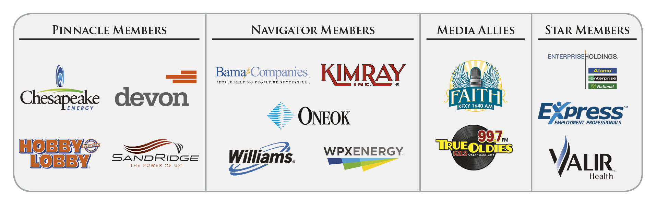
- VOLUNTEER RECOGNITION:
OK Ethics relies primarily on volunteers to achieve the organization’s successful pursuit of Oklahoma’s values of integrity at work. It takes leadership and teamwork to host these exciting events!

Special Kudos & Farewell:
● Dr. Earlene Smith, Retired, - Original mentor to students, Student Ethics Challenge and Ambassador Team volunteer. Moving to St. Louis.
● Dr. Allison Garrett, Vice President, Oklahoma Christian University – Host to Student Ethics Challenge. Moving to Vice President position with Abilene Christian University.
Join our team - Contact our leadership
Membership & Recruiting: Lynda Mobley, ONG, OK Ethics VP of Membership,
(405) 551-6774 Lynda.Mobley@oneok.com
Ambassadors: Linda Streun, Director of Human Resources,
Ideal Homes, lindastreun@ideal-homes.com
Registration: Mark Neumeister, D. R. Payne; 272-0511; moneumeister@drpayne.com
Registration Team: These dependable individuals show up every month to diligently record our guests’ attendance and handle the collection of fees:
- Mark Neumeister, Chairperson; D. R. Payne & Associates
- Joe Walker, Chairperson (Prepaid members); Wilbanks Security
Team Members:
  - Mary Vaughn, CPA, JMA Energy
  - Mary Kay Huggard, Principal Technologies, Inc.
  - Marvinette Ponder, Devon Energy
Ambassador Team: These friendly people welcome our guests each month and assist in helping them locate seats. They also arrive early to help distribute agendas and assist with name tags.
Team Leader: Linda Streun, Ideal Homes of Norman: Chairperson
Team Members:

- Scott Harris – Oklahoma Baptist University
- Wayne Hart – Legal Shield
- Brent Martens – Accounting Principals
- Larry Musslewhite – Retired
- Connie Root - Walker Companies
- Lynn Willis – Metro Technology Centers

Agendas: Metro Technology Centers, Quality Services and Media Departments
Accounts Receivable Reconciliation: Susan Pate, Stinnett & Associates
CPE’s: Michael Mount, CPA, Oklahoma Accountancy Board
Facilities & Logistics: Jamie Potter, Eide Bailly
Name tags: Sue Miller, Accel Financial Services
Member Care Coordinator: Jalisha Petties, Accounting Principals
AV & PowerPoint: Connie Rutz, MaximumMultiMedia Productions

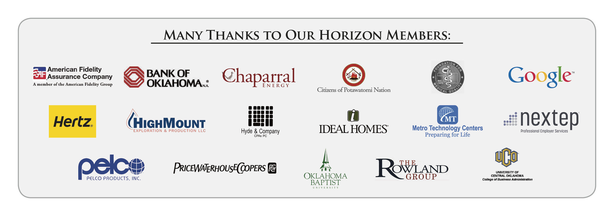
- Upcoming Events: Oklahoma City Chapter Shannon Warren, Founder, OK Ethics
September 5 – Statewide Educators Ethics Symposium
(Southern Nazarene University)
Mary C. Gentile, Ph.D., is Director of Giving Voice to Values (GVV), a business curriculum launched by Aspen Institute and Yale SOM, now based and funded at Babson College. GVV is a pioneering approach to values-driven leadership that has been featured in Financial Times, Harvard Business Review, Stanford Social Innovation Review, McKinsey Quarterly, BizEd, etc. and piloted in over 250 business schools and organizations globally. The book – Giving Voice To Values: How To Speak Your Mind When You Know What's Right – is out from Yale University Press (www.MaryGentile.com). Gentile is Senior Research Scholar at Babson College; Senior Advisor, Aspen Institute Business & Society Program; and independent consultant. Previously Gentile was a faculty member and manager of case research at Harvard Business School.
Agenda:

8:00 - Continental Breakfast & Networking
8:30 - OK Ethics' Opportunities
- Prize-winning academic papers: National Competition in San Antonio
- Statewide Student Ethics Challenge
- Professor's Insights
- Case Studies
9:30 - Dr. Gentile's workshop, "Giving Voice to Values"
- Reframing our approach – the Yale/Babson Model
- Best practices in creating a campus
that fosters integrity
11:45 - Adjourn

While at Harvard Business School (1985-95), Gentile was one of the principal architects of the innovative educational program, Leadership, Ethics and Corporate Responsibility. Gentile co-authored Can Ethics Be Taught? Perspectives, Challenges, and Approaches at Harvard Business School (with Thomas R. Piper and Sharon Parks, Harvard Business School Press, 1993, translated into Japanese and Hungarian).

Other publications include Differences That Work: Organizational Excellence through Diversity; Managing Diversity: Making Differences Work; Managerial Excellence Through Diversity: Text and Cases, as well as numerous articles, cases, and book reviews in publications such as Academy of Management Learning and Education, Harvard Business Review, Stanford Social Innovation Review, Risk Management, CFO, The Journal of Human Values, BizEd, Strategy+Business, etc. Gentile served as Content Expert for the award-winning interactive CD-ROM, Managing Across Differences (Harvard Business School Publishing 1996).

Gentile holds a bachelor's degree from The College of William and Mary (Williamsburg, VA) and an M.A. and Ph.D. from the State University of New York at Buffalo.

September 12 – Integrity Wins: Facing the Herd

Ever face being trampled by “The Herd” – those who don’t want to play by the rules and will run over anyone who gets in their way? Learn the key components of building emotional shields that will help strengthen your character in the face of ethical challenges:
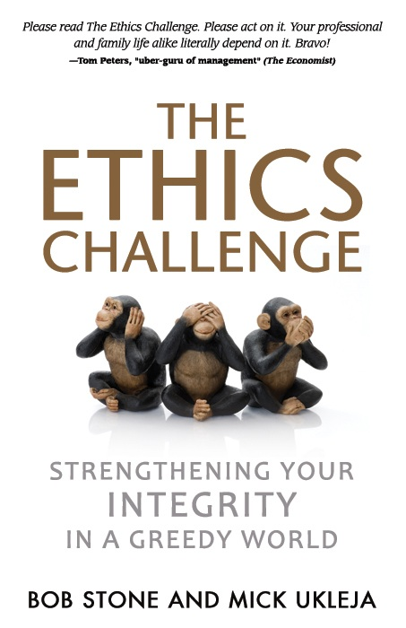
E = Embrace your purpose

T = Test excuses

H = Harness your moods

I = Insist on integrity

C = Cultivate trust

S = Self-differentiate

Mick Ukleja, co-author of The Ethics Challenge: Strengthening Your Integrity in a Greedy World will share insights that will help individuals move beyond compliance into a courageous leadership methods that transform organizations. His ideas have been praised by prominent leaders such as business guru Tom Peters who said, “Please read The Ethics Challenge. Please act on it. Your professional and family life alike literally depend on it.”

Ken Blanchard said of the book: “When you read The Ethics Challenge, you’ll see that ethics is alive and well in America. Bob and Mick have written an important book for today’s leaders.”

His last book, Who are You and What Do You Want? Four Questions That Will Change Your Life, was praised by legendary coach John Wooden. He has also written books about Managing the Millenials and has worked with a wide variety of clients such as Boeing and the Special Olympics.

Mick is Chairman of the Board of Trustees for the Astronauts Memorial Foundation at the Kennedy Space Center which oversees the center for space education. He has been featured on Fox News, CNN, Fox Business Network, NBC, and numerous publications.
Recommended for 1 CPE in Ethics
________________________________________________________________

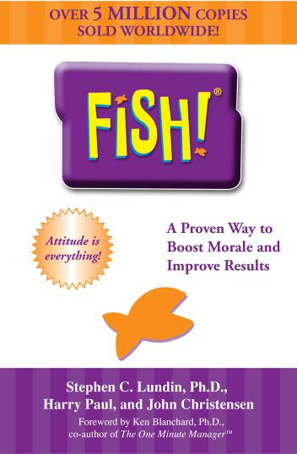
November 15, 2012 - OK ETHICS LAUNCH OF 10 YEAR ANNIVERSARY!
LUNCHEON - OKLAHOMA GOLF & COUNTRY CLUB
Fish! and The Power of Ethics
presented by
Harry Paul, co-author Fish!
Presented by Harry the Fish! Guy; co-author of the best-selling book that creates fun at work while maintaining one’s integrity. With a Ph.D. in experience, Harry worked with Ken Blanchard and collaborated with Norman Vincent Peale on the launch of the book, The Power of Ethical Management. You will leave this session feeling invigorated and inspired!

Recommended for 1 CPE in Ethics

Help spread the word:
Please post this page on your company’s bulletin board.

TULSA CHAPTER ACTIVITIES:

August 24
Women CEO’s:  How Ethics Paves the Way to the Top | 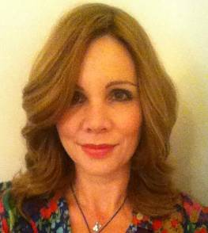 | 
Panel Includes:  Christine O’Connor  President,  GEA Rainey(Not pictured) | Teresa Knox  Founder and Owner,  Community Care College,  Clary Sage College,  Clary Sage Salon franchise,  and Oklahoma Technical College | Wendy A. Buxton  President,  LynnCo Supply Chain Solutions, Inc.

_______________________________________________________________________________

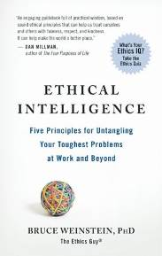
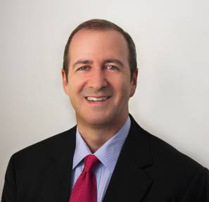
September 27
"Ethical Intelligence™: How Good People Make Great Things Happen"

presented by
Bruce Weinstein, Ph.D., The Ethics Guy

_______________________________________________________________________________
October 25
"A Champion's Perspective" presented by Jay Wilkinson, son of legendary OU Coach Bud Wilkinson
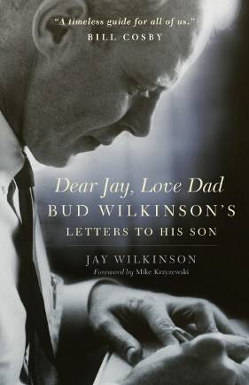
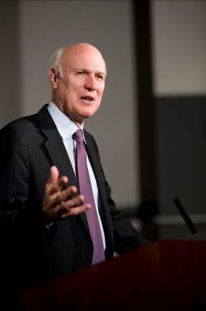

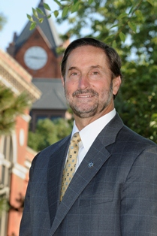
- Introduction of Speaker –
Dr. Don Betz,
President
University of Central Oklahoma

University of Central Oklahoma President Don Betz, Ph.D., has enjoyed a distinguished career in higher education that spans more than 40 years, developing a reputation for teaching and encouraging students, and leadership development. He also is known for his diplomacy skills,
developed through his international activities, most notably with the United Nations and its affiliated
non-government organizations.
Enhancing that reputation, he currently is serving a three-year term on the International Association of University Presidents (IAUP) executive committee and as chair of its North American Council. President Betz was selected to attend the 2011 Fulbright-Hays Seminar for Presidents Scholar, held in Oman and Jordan. The purpose was to explore opportunities for future program development in the region with stakeholders on American college campuses.

Becoming Central's 20th president in August 2011 meant a special homecoming for President Betz, who served as Central's provost and vice president of Academic Affairs from 1999-2005. Returning to Central was coming back to a university where he had developed several initiatives and programs that had helped transform Central into its stature today as one of the leading metropolitan universities in the nation.

He currently serves as a member of the founding implementation committee for the American Association of State Colleges and Universities (AASCU) American Democracy Project and is chair of Creative Oklahoma Inc. He is also a member of the Oklahoma Academy, Leadership Oklahoma, and the Universities and Colleges President's Climate Commitment.

Prior to returning to Central, he served as president of Northeastern State University in Tahlequah, Okla., since July 2008. Before that, he served as chancellor at the University of Wisconsin-River Falls from 2005 until his appointment at Northeastern, and as provost and vice president for Academic Affairs at Palmer College, Davenport, Iowa, from 1994-1999. In the 23 years prior, he fulfilled various capacities at Northeastern, including the vice president of University Relations, a professor of Political Science, as well as the executive director of the Educational Foundation and assistant to the president.
“Transformative leaders bring passion and integrity to their roles in organizational change. Business leadership research surveys of followers--as well as investors-- show they expect consistent ethical behavior of leaders who must place the betterment of society and their business above their own personal gain. This demanding, multi-faceted role is evolving within a context of accelerating technological change and continuing globalization. This confluence of circumstances escalates ambiguity and the perennial need for defining and refining the tools for adaptive change. The role of the ethical leader is imperative to successfully meet the multi-dimensional challenge of change.” - President Betz

From 1982 through 2003, President Betz worked for and with the United Nations on Middle East issues. He founded and chaired the International Coordinating Committee on the Question of Palestine (ICCP), a UN-affiliated non-governmental organization (NGO) network pursuing peace in the Middle East based on UN resolutions. His extensive international experience includes service with the University of Pittsburgh's Semester-at-Sea, Chapman College's World Campus Afloat, and journalistic experience in the Middle East.

A frequent writer and speaker, President Betz has addressed international, educational and motivational topics, and has worked with newspapers, radio and television. His life-long interest in global issues and his passion for promoting cross-cultural understanding has led him to more than 80 countries.

- The Virtue of Integrity
  - Integrity provides the underpinning for the responsible exercise of our rights and responsibilities as human beings.
  - Integrity leads to empowerment and excellence.
  - Integrity is an essential trait of a valued citizen.

- Integrity is a vanishing commodity today. Personal standards are crumbling in a world that has taken to hot pursuit of personal pleasure and shortcuts to success.
- “The first key to greatness,” Socrates reminds us, “is to be in reality what we appear to be.” To earn trust a leader has to be authentic. For that to happen, one must come across as a good musical composition does- the words and the music must match.
- Everything rises and falls on leadership.
- The secret to rising and not falling is integrity.
- Reasons why integrity is so important:
- Integrity builds trust. If my people understand me, I’ll get their attention. If my people trust me, I’ll get their action.” For a leader to have the authority to lead, he needs more than the title on his door. He has to have the trust of those who are following him.
- Character makes trust possible. And trust makes leadership possible.
You don’t build trust by talking about it. You build it by achieving results, always with integrity and in a manner that shows real personal regard for the people with whom you work. When a leader’s character is strong, people trust her, and they trust in her ability to release their potential. That not only gives followers hope for the future, but it also promotes a strong belief in themselves and their organizations. The 21 Irrefutable Laws of Leadership.
- Your character is your destiny.
Integrity has high influence value.
Emerson said, “Every great institution is the lengthened shadow of a single man. His character determines the character of the organization.” That statement “lines up” with the words of Will Rogers who said, “People’s minds are changed through observation and not argument.” People do what people see.
- Integrity facilitates high standards.
Leaders must live by higher standards than their followers. There’s a tendency today to absolve individuals of moral responsibility and treat them as victims of social circumstance. You buy that and you pay with your soul. What limits people is a lack of character. When the character of leaders is low, so are their standards.
- Integrity results in a solid reputation, not just an image.
Thomas Macauley said, “The measure of a man’s real character is what he would do if he would never be found out.” Image promises much but produces little.

- Integrity never disappoints.

Integrity is not a given factor in everyone’s life.
It is a result of self-discipline, inner trust, and a decision to be relentlessly honest in all situations in our lives. Developing the Leader Within You

The Leadership Challenge: Ten Commitments of Leadership

Challenging the Process
1. Search out challenging opportunities to change, grow, innovate, and improve.
2. Experiment, take risks, and learn from the accompanying mistakes.

Inspiring a Shared Vision
3. Envision an uplifting and ennobling future.
4. Enlist others in a common vision by appealing to their values, interests, hopes,
and dreams.

Enabling Others to Act
5. Foster collaboration by promoting cooperative goals and building trust.
6. Strengthen people by giving power away, providing choice, developing
competence, assigning critical tasks, and offering visible support.

Modeling the Way
7. Set the example by behaving in ways that are consistent with shared values.
8. Achieve small wins that promote consistent progress and build commitment.

Encouraging the Heart
9. Recognize individual contributions to the success of every project.
10. Celebrate team accomplishments regularly.

Programs Focused on Integrity - (Not affiliated with OK Ethics)

Character Council of Central Oklahoma …cultivating good character

The Character Council of Central Oklahoma is an organization that educates, equips and empowers others to create a culture of good character within Central Oklahoma. Their vision is that Central Oklahoma will become a model community of good character. Upcoming programs include:
August 28: Rodney Ray, City manager of Owasso, City of Character
Rodney J Ray has been active in municipal government since 1976 when he was employed by the City of Jenks as its City Manager. Prior to entering city government, he served as an Administrative Assistant to Congressman Ed Edmondson and was the Director of Community Services for the Governor’s Office of Community Affairs and Planning. He is currently the City Manager for the City of Owasso and has served Owasso citizens for over twenty years.

This month's Character Trait:
Thoroughness vs. Incompleteness
"knowing what factors will diminish the effectiveness of my work or words if neglected"

Cost is $15 per person; Reservations made via luncheon@characterok.org
I
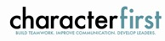
For nearly nine years, we have been inspired by our friendship with Character First. Leaders with this organization provided the wisdom and insight for
OK Ethic's Guiding Principles. Go to www.characterfirst.com to learn more about tools to help you integrate character and ethics into your organizational culture, or contact John Burnett at 405-815-0001

Seminar Aug 29: "Orientation Training"
The Character First Orientation Training is a hands-on, practical session on how to implement Character First in your organization.

Seminar Sept 5-6: "Ethics in Law Enforcement"
Law enforcement officers face pressure from many angles. One wrong move can destroy community trust and stain reputations for years.
This 2-day training event will teach you how to recruit officers with character and competence, how to establish clear ethical standards, and how to implement character initiatives for inmates and offenders.

Seminar Oct 16: "Coaching & Mentoring at Work"
Part of developing your workforce is coaching employees to achieve personal and professional goals, which benefits the whole organization. However, learning how to coach others in the workplace requires an in-depth understanding of your own leadership style and the leadership style of those you help.

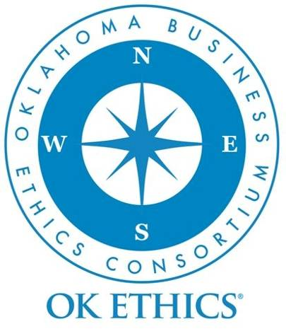
INTERESTED IN RECEIVING OK ETHICS
MONTHLY MEETING NOTICES?
OKC: Contact Jalisha Petties, Member Care Coordinator
at (405) 889-0498 or via email okethics@yahoo.com

Tulsa: For more information about Tulsa activities, contact Michael Oonk,
President – Tulsa Chapter, (918) 481-3822

General Program Disclaimer:

Members of the Oklahoma Business Ethics Consortium frequently share information concerning various issues and developments that may have legal implications. The discussions, commentary, and handouts at Consortium meetings or presentations to other organizations are for general informational purposes only. They cover only some aspects of the subject topic, and do not constitute a complete legal analysis of the topic or how it might apply to any particular set of facts. Before taking any action based on information presented during a Consortium event, participants are encouraged to consult a qualified attorney. The observations and comments of presenters at Consortium meetings and networking are the views and opinions of the presenter and do not constitute the opinion or policies of the Consortium or any of its members. Presenters are respectfully requested to avoid profanity, preaching, politics, put-downs and self-promotion during their lectures

Like OK Ethics on FaceBook

REMINDER: PLEASE PICK UP CPE’S
AT CONCLUSION OF EVENT.

